

**CSCI 5308: Advanced Topics in Software Development**

**GROUP 11**

| **HEMANTH NADIPINENI** | **B00899473** |
| --- | --- |
| **SANGRAMSINH MORE** | **B00903585** |
| **TRUSHITA MAURYA** | **B00913134** |
| **NISHIT MISTRY** | **B00911296** |
| **SUBASH NARAYANAN** | **B00899481** |

**TA:** MANJINDER SINGH

**PROFESSOR:** TUSHAR SHARMA

**USAGE SCENARIO**

**Creating a watch group:**

1) Users can register into the application.

2) Log in-to the application.

3) After logging in users can access the home page with a list of movies categorized into Trending, Top rated, Action movies.

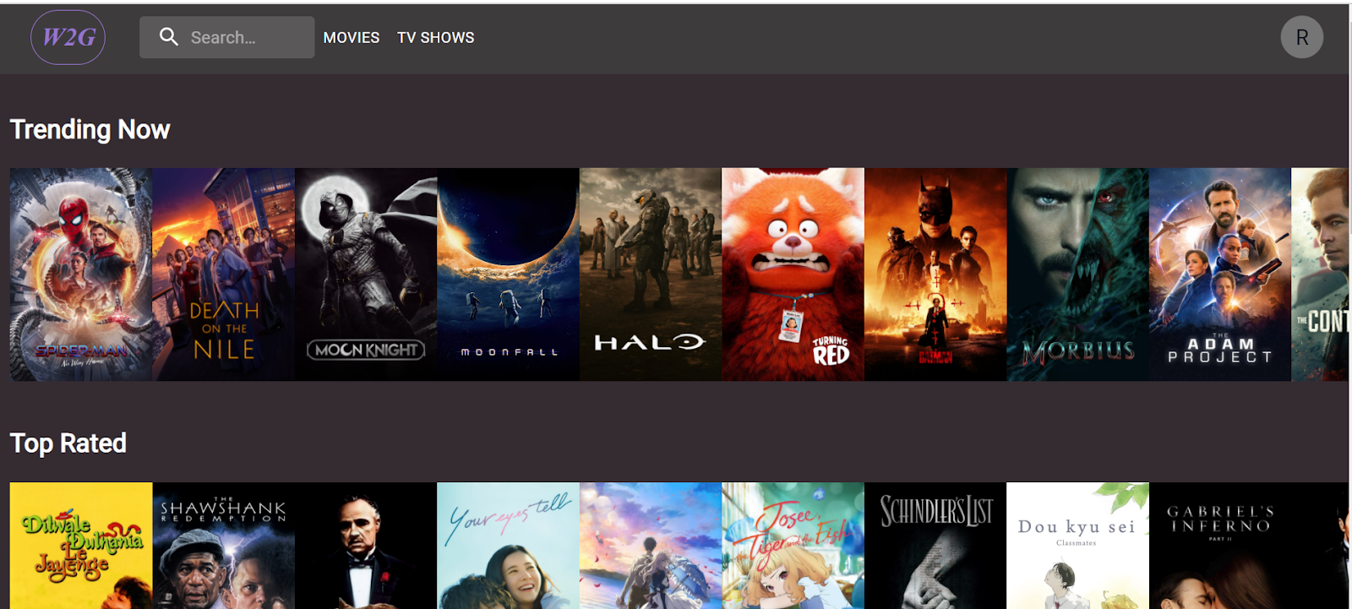

4) By Clicking on any particular movie user can access the movie content page.

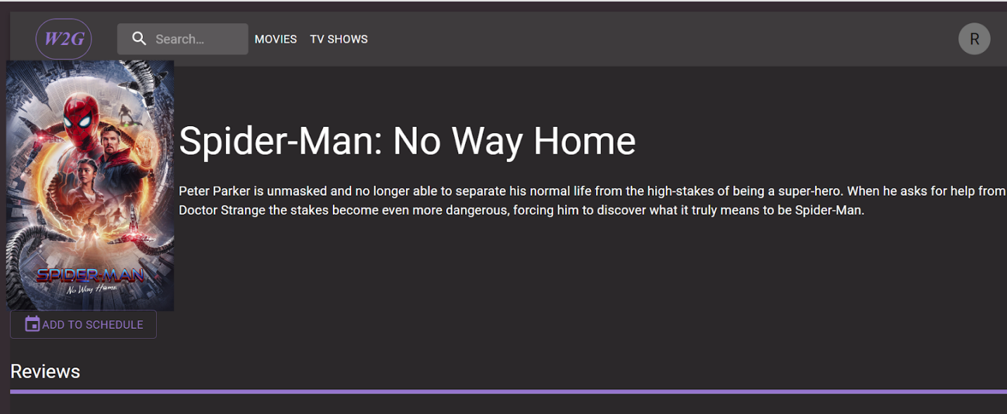

5) Inside the content page users can see all the visualization details for a particular movie and different watch groups that exists.

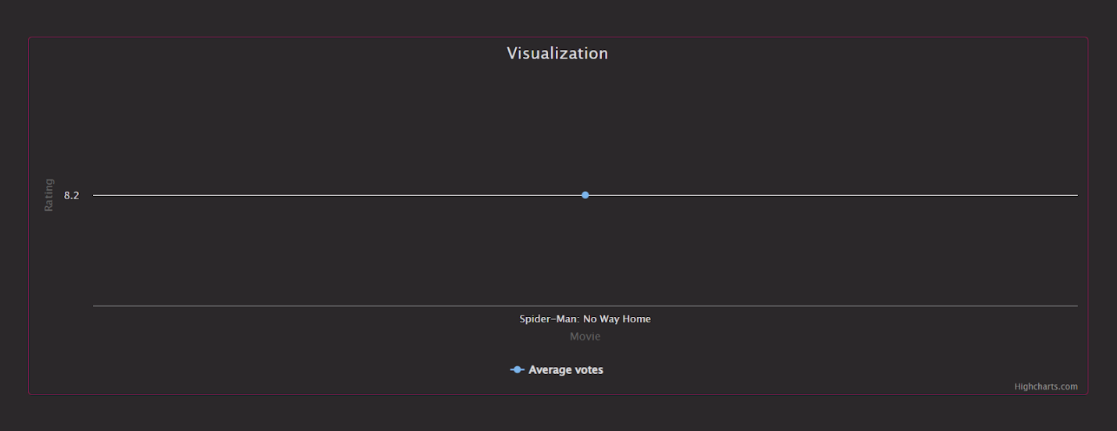

6) Click on the add to schedule button to view the calendar.

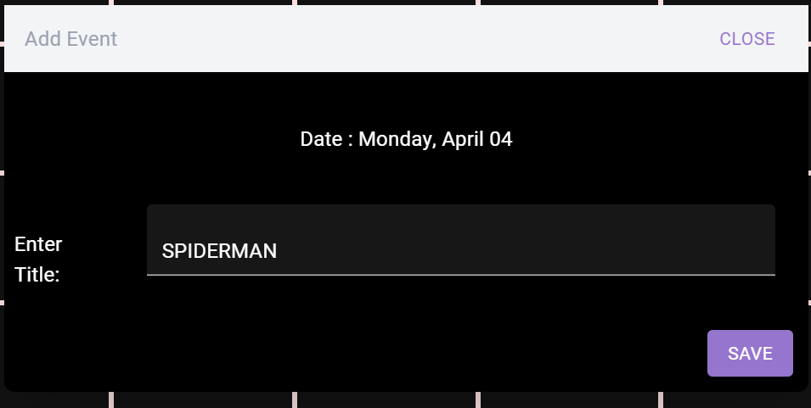

7) Create a new event by giving a Title.

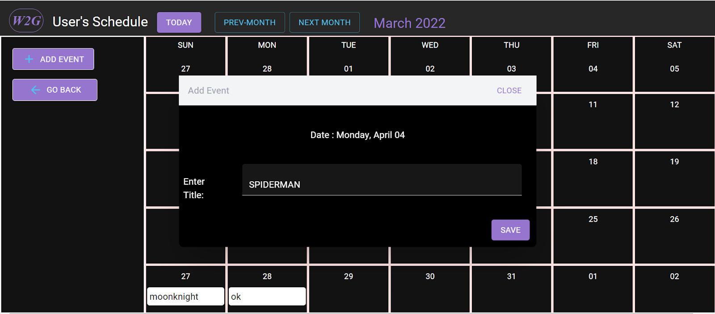

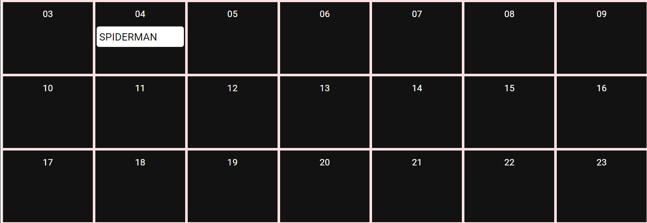

8) This will create a new event and create a watchgroup.



**Visualization:**

1) You can view the rating of a particular movie by clicking on the home page.

2) Here you see a list of all the movies that exist and clicking on a particular movie or a TV show will take you to the content page where you can see the rating across seasons or a particular movie.

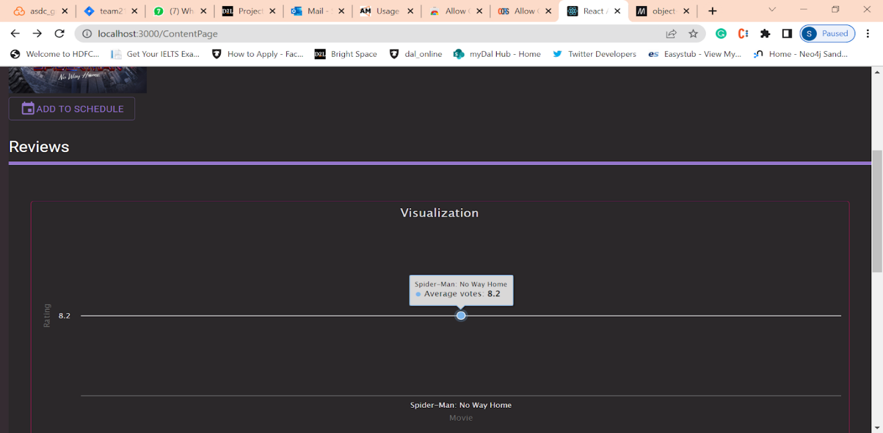

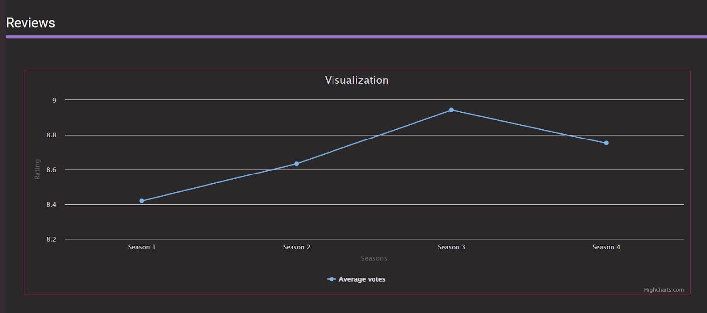

**Scheduler:**

1) Users can see the schedule details by going to any movie on the home page.

2) Will be redirected to the content page and the content page will have an add to schedule button and from there we will have a calendar view where you can see an option to view different months, and an option to add an event which will create a new watch group.

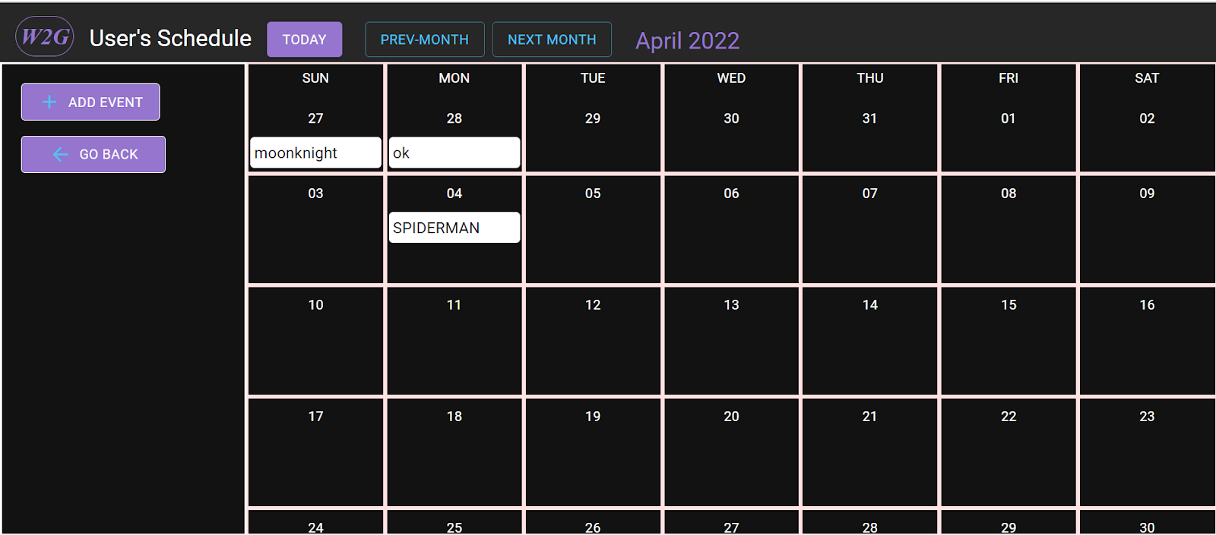

**Joining a WatchGroup:**

Watch group belongs to a particular movie.

**Way 1:**

1) From home page click on a particular movie will redirect you to content page

2) Content page will have watch Groups and you can join any watch groups that exist.

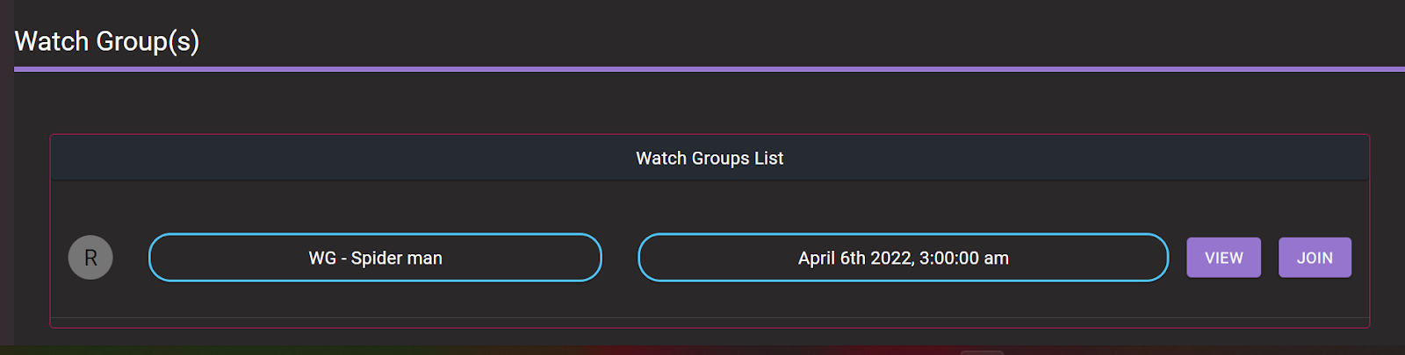

3) Just click the JOIN button to join the watch group.

**Way 2:**

1)Use the search button to get all the movies, click on a movie.

2) Will be redirected to the movie content page where you can see all the existing watch Groups.

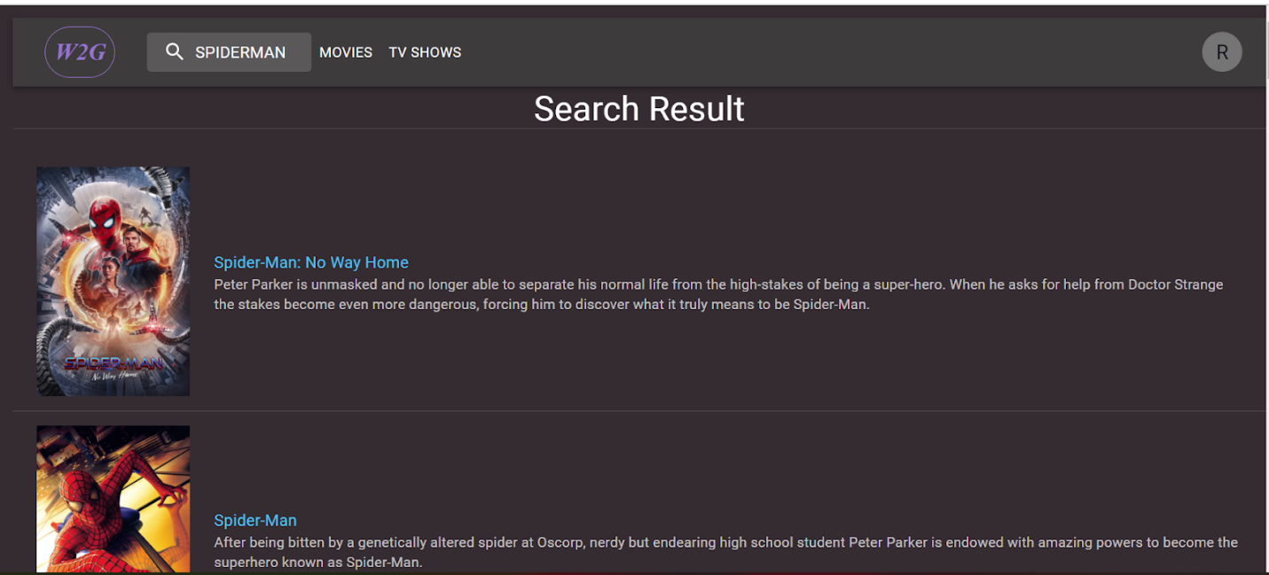

Here you see all the watch groups for a particular movie and you can join any watch group that exists.

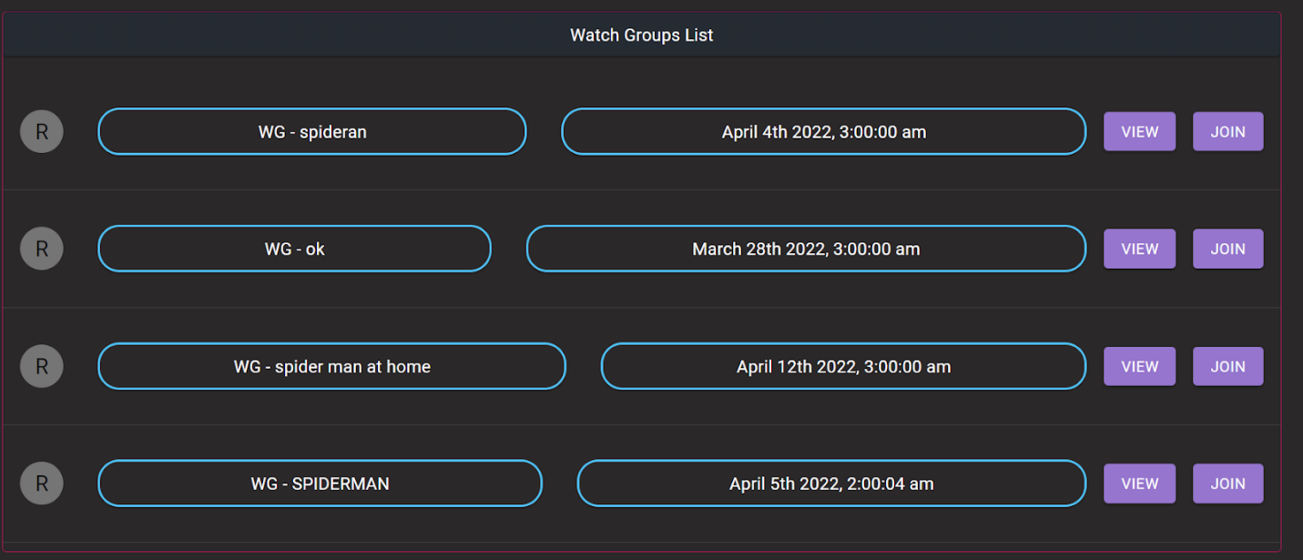

**Viewing all my watch Groups:**

1. Register / login
2. After Login
3. Go to profile
4. In the profile page you can access all the watch groups.

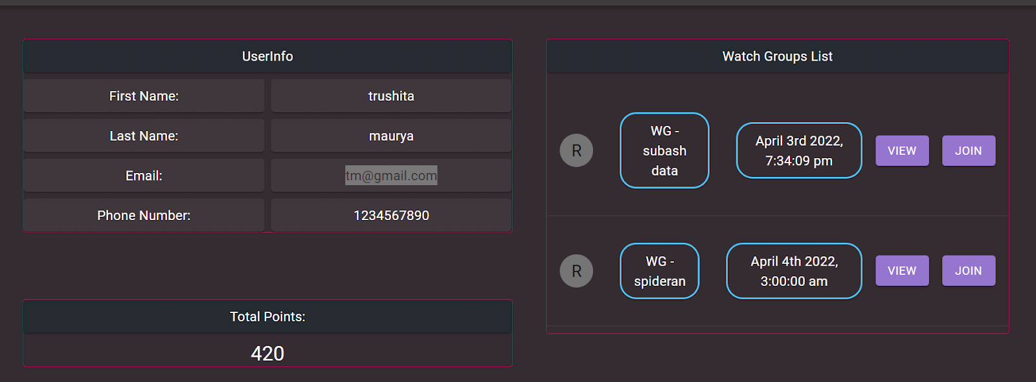

**Leaderboard for a particular watch Group**:

On reaching a particular home page you can see a list of watch groups for a particular movie.

On joining a particular watch group, you can go to the particular watch group and then access the leader board for each watch group.

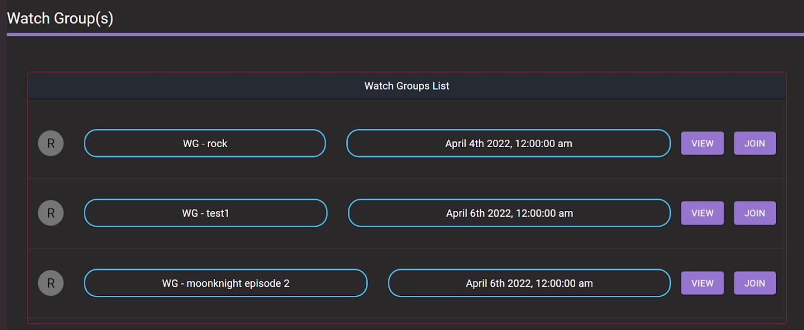



**View all the existing post:**

1. On reaching the content page and reaching a particular watch group for a particular movie.
2. View a particular watch group which contains leader boards and users belonging to this particular watch group, and an option to view the discussion thread.
3. On clicking a discussion thread, we can see all the existing posts, and option to create a new post.

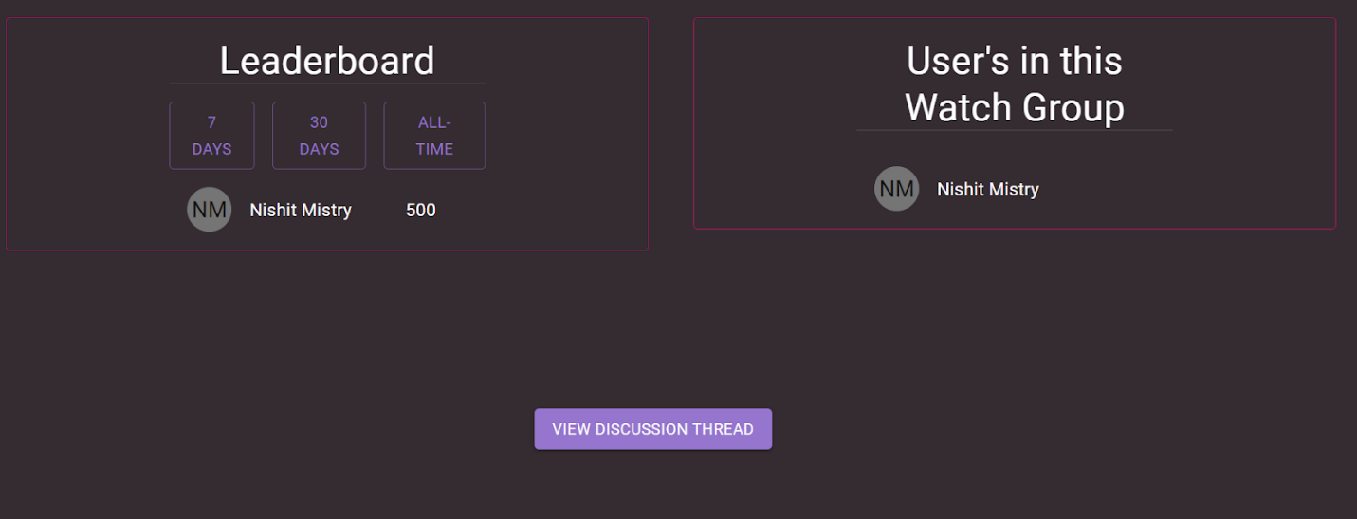

4) You can view the post by clicking on the view button and like it.

5) After you click on the view button you can see the post and comments related to it.

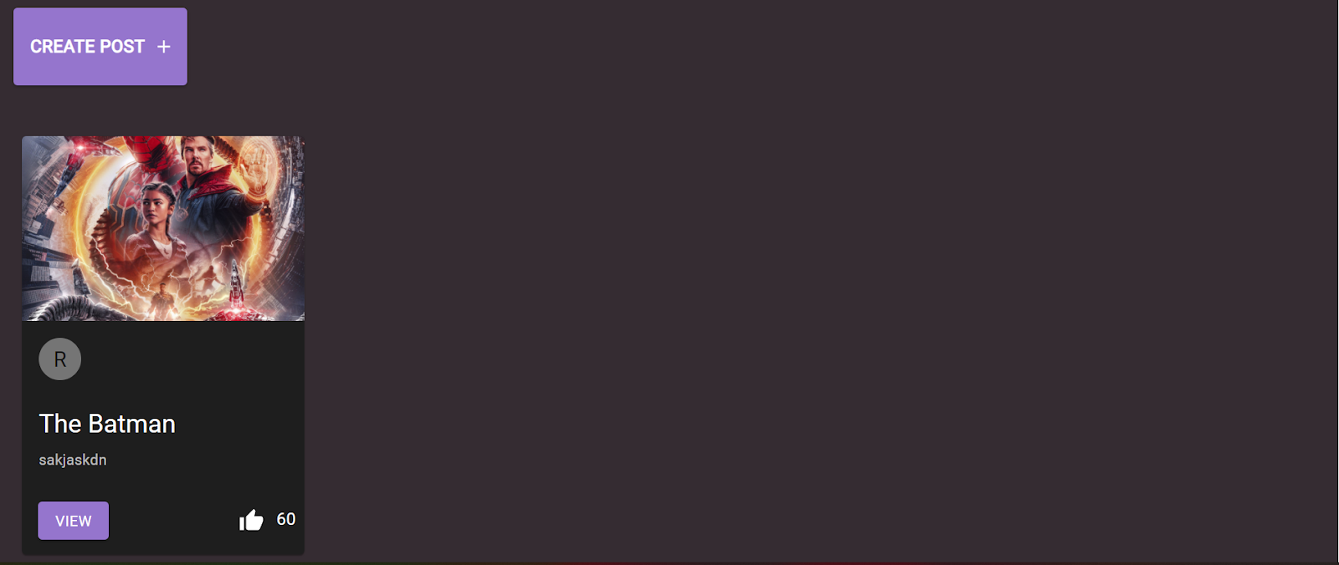

**Creating a post:**

1. On reaching the content page and reaching a particular watch group for a particular movie.
2. View a particular Watch group which contains leader boards and users belonging to this particular watch group, and an option to view the discussion thread.



1. On clicking a discussion thread, we can see all the existing posts, and option to create a new post.

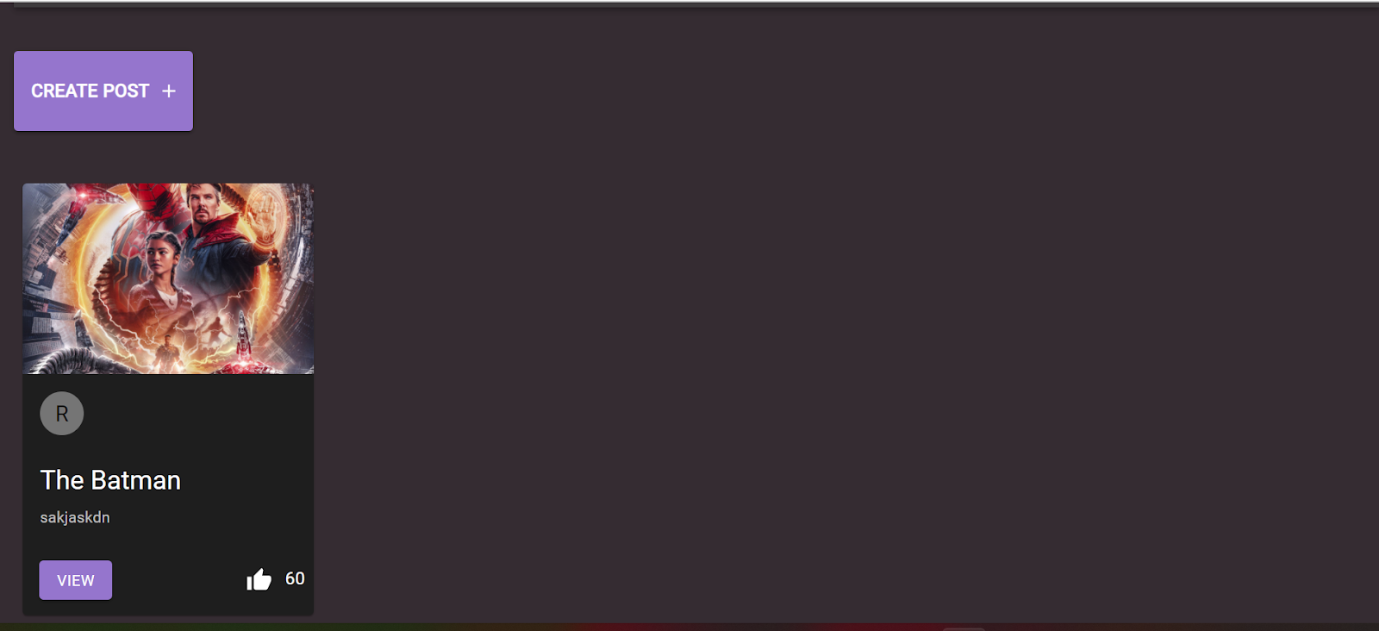

4) Click on the create post to reach the create post page where you can find the form to create a new post.

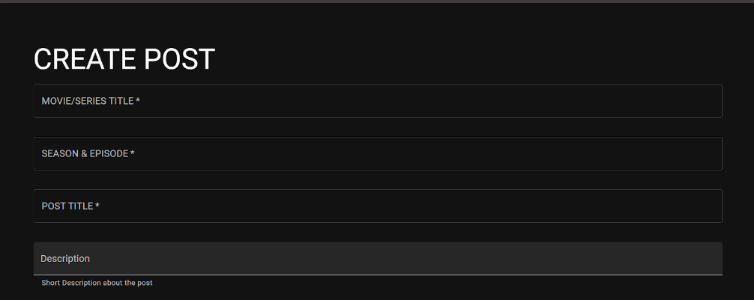

**Application Modules:**

**Ratings Visualizer:**

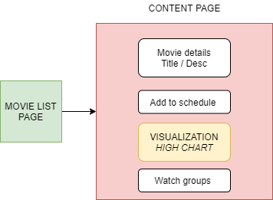

Ratings Visualizer Module is useful for a user to make better decisions on making choices for a particular show or movie. It provides graphical presentations of ratings in the form of a line graph. Here, X - Axis represents either the seasons or the name of the movie and Y - Axis represents the ratings for each season/movie

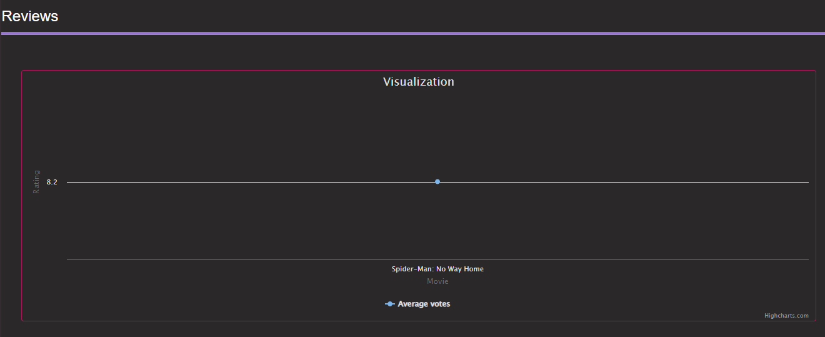

***Movie Rating***

**Season Rating Calculations:** TMDB API is used to retrieve ratings for shows and movies. While the API is straightforward to get ratings of movies but to retrieve ratings for shows, we required more information from different API calls.

We applied an algorithm to calculate the ratings of each episode based on the number of votes and found the average rating for that particular season. This same logic was applied to all seasons. This data was collected and transformed to the needs of the High Charts library that helps in plotting the graph.

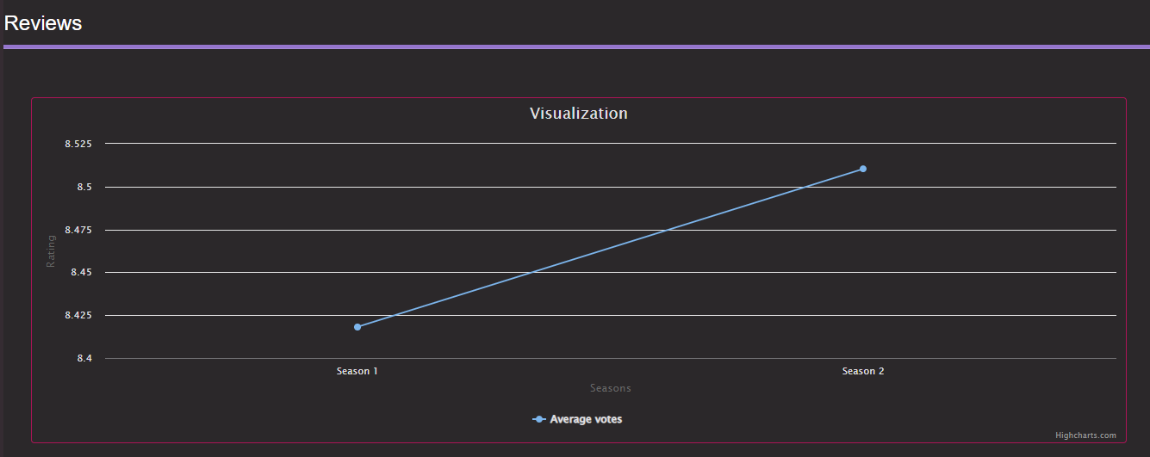

**Season Rating**

**Scheduler:**

For Scheduler i.e., Calendar view we have developed it using CSS Styling and JavaScript functions. The Dayjs node module library is used for operating and manipulating on dates.

More information on Dayjs can be found at : <https://www.npmjs.com/package/dayjs>

The following GitHub Repository was also referred for creation of this component: [GitHub repository reference link](https://github.com/3stbn/google-calendar-clone)

The Calendar view in our application allows users to add events to their personalized calendars. The calendars can be used to manage watch events which the user wants to create.

The Calendar view is the core component of our scheduler as it would allow us to schedule and manage watch events across the application among all its users. The main purpose of this component is to give users the option to check their schedules and decide the appropriate time to schedule watch events according to their convenience.

The Following are some of the Major Features which Scheduler provides:

Add Watch Event: The application provides a functionality to directly add an event through the content page of the application, the user needs to browse to their desired content page where they can find an option to directly add that particular event to their respective calendar.

Delete Watch Event: The application also provides a feature where users can navigate to their own profile page where they can find their respective calendar. The calendar view will allow that user to delete a watch event if they click on that event from the calendar and select delete option (Only the user who created the event would have the option to delete that event).

Manual Event Add: The application also has a feature where users can click on the Add Event button in their calendar to manually add any watch event.

The Following are some the workflow paths to the Scheduler:

1. From Application’s main page:

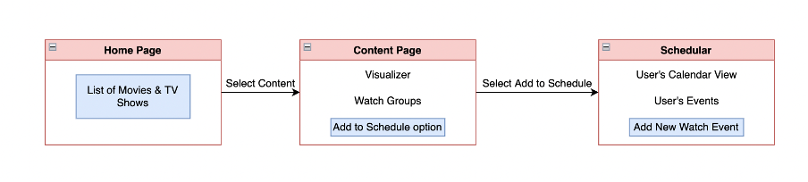

2. From User profile page:

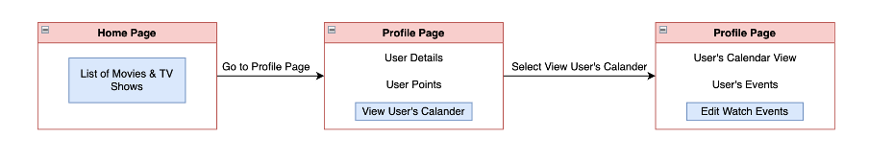

3. Discussion Thread:

Discussion thread feature is an important part of the application where each TV / SERIES or show will have different watch groups, and for each watch group, there is a leader board option to view all the users and their scores, and an option to view discussion thread.

Discussion will have a list of posts belonging to a particular watch group and watch groups in turn belong to a particular TV show or movie. Inside the discussion thread, we have many posts created by the users and option to view the post, and upvote (like) it. Discussion threads can also be accessed through the user profile page and in turn access the watch groups and discussion threads inside it.

Each post will have a list of comments and an option to reply to that comment through which they can interact and discuss theories and opinions about movies or shows.

**Functionalities:**

Create Post: Create post is where a user creates a new post and gives a description [theories] and adds comments for more info and initiates a discussion.

Total Points: Total points is calculated for a particular user for a particular watchgroup. Points are accumulated through upvotes by other users on the post created by a particular user.

Upvote: This is where the post is upvoted by others users and in turn allocate points for the post creator used to rank in the leaderboard.

Leaderboard: Leader board is a rank of people based on points allocated through upvotes on posts by other users.

Comment: Comments can be added to a post by other users and participate in discussion and share their views and opinions.

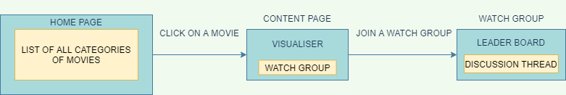

**Workflow on how to reach Discussion thread**

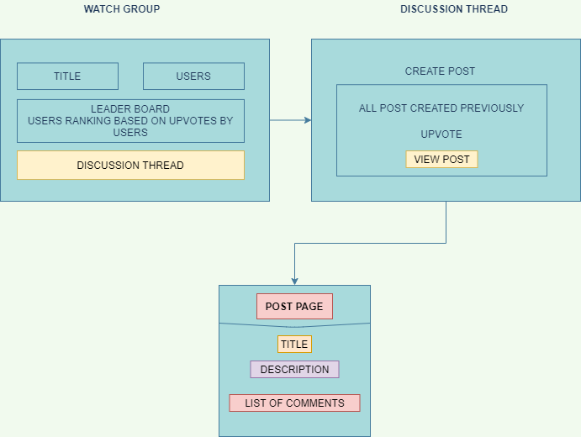

**Workflow on reaching a post**

**Comments:**

The Comments Section in our application can be found under posts which are contained under discussion threads. The Comments component allows the user to provide their opinion around the post which is being discussed.

For creation of the comments section JavaScript functions have been created for its logic and we have used Material-UI’s components for designing its user interface.

The Comment component is a sub-part of our Discussion thread feature. The Comment Component has various features which are mentioned below:

**Add Comment**: The comment component allows users to add a comment under any post. The user simply needs to navigate to the bottom of the post to reach the comments section and there they can type their comment under the “Add Comment” text field and hit the submit button to post their comment. After posting the comment the user can see their comment posted under the comments tab with their username and timestamp.

**Reply comment:** The application also allows the users to reply to other posted comments. The reply comments are treated as sub-comments. The sub-comments can also be sub-commented in our application. The user needs to select the reply option under a comment to reply to that particular comment.

**Delete Comment:** The application also allows the user to delete their posted comments. The user simply needs to click on the delete option which is under the comment section in order to delete their comment.

**Latest comments first:**  The comment component is designed in such a way that the latest comments are seen on the top.

The Following is the workflow path to the Comment Component:

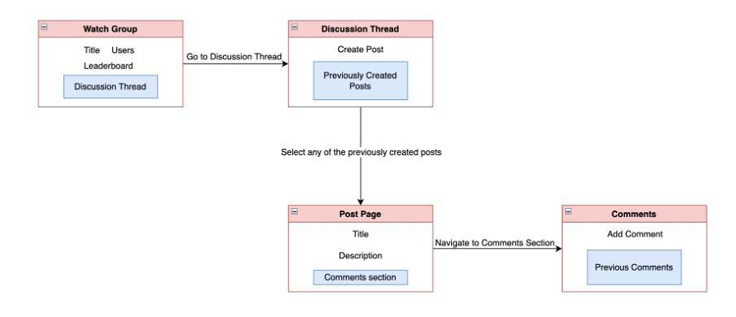

**General Workflow of the Application:**

The application starts with the landing page with a login form where a user can login with his/her credentials. If the person doesn’t have an account, he/she can click on the link to register that appears at the bottom of the login form. Once the user is registered, the application will redirect the user to the home page. After logging in as well, the user will be redirected to the homepage.

## References

[1]"Before you continue to YouTube", *Youtube.com*, 2022. [Online]. Available: https://www.youtube.com/playlist?list=PLJM1tXwlGdaf57oUx0rIqSW668Rpo_7oU. [Accessed: 06- Apr- 2022]

[2]"GitHub - akashyap2013/LeaderBoard_React_App: In this application, we are going to look at how to make leaderboard in the react application.", *GitHub*, 2022. [Online]. Available: https://github.com/akashyap2013/LeaderBoard_React_App. [Accessed: 06- Apr- 2022]

[3]"GitHub - monsterlessonsacademy/monsterlessonsacademy at 144-react-comments", *GitHub*, 2022. [Online]. Available: https://github.com/monsterlessonsacademy/monsterlessonsacademy/tree/144-react-comments. [Accessed: 06- Apr- 2022]

[4]"GitHub - 3stbn/google-calendar-clone: Google calendar clone made with react", *GitHub*, 2022. [Online]. Available: https://github.com/3stbn/google-calendar-clone. [Accessed: 06- Apr- 2022]